**Model Development Phase Template**

|  |  |
| --- | --- |
| Date | 3 July 2024 |
| Team ID | 739698 |
| Project Title | Acoustic Fire Extinguishing Prediction |
| Maximum Marks | 4 Marks |

**Initial Model Training Code, Model Validation and Evaluation Report**

The initial model training code will be showcased in the future through a screenshot. The model validation and evaluation report will include classification reports, accuracy, and confusion matrices for multiple models, presented through respective screenshots.

**Initial Model Training Code**

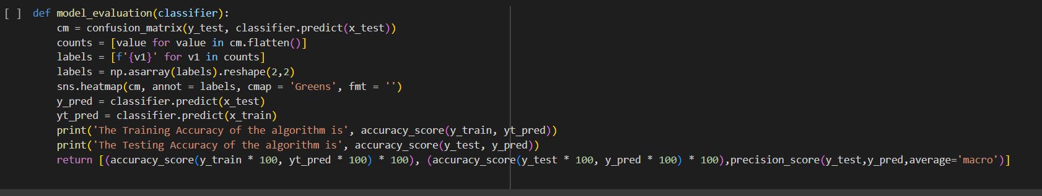

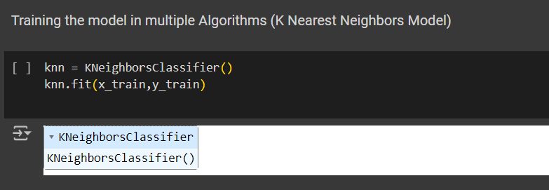

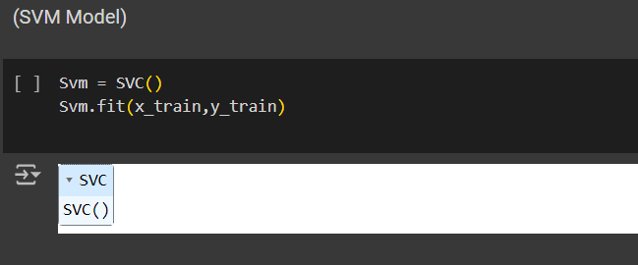

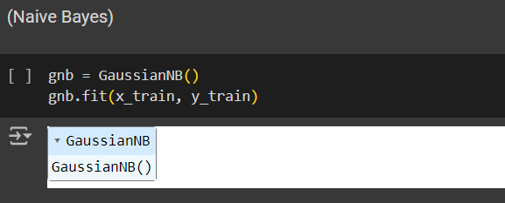

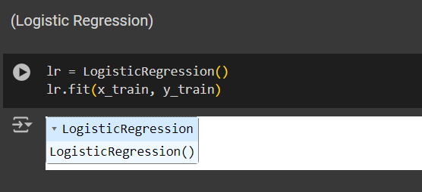

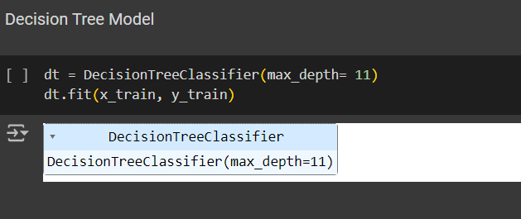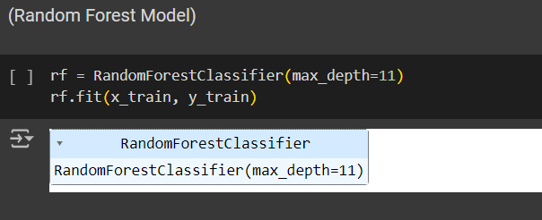

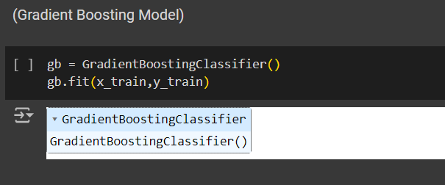

**Model Validation and Evaluation Report:**

|  |  |  |  |
| --- | --- | --- | --- |
| **Model** | **Classification Report** | **Accuracy** | **Confusion Matrix** |
| KNN |  | 94&91 | - |
| SVM |  | 88&89 | - |
| Naïve bayes |  | 86&87 | - |
| Logistic regression |  | 87&87 | - |
| Decision Tree |  | 98&94 | - |
| Random Forest Model |  | 98&95 | - |
| Gradient boosting model |  | 95&94 | - |